- INTRODUCTION

1.1 ABSTRACT
"KNOWZILLA" is an innovative quiz trivia website designed to provide users with an engaging and interactive platform for testing their knowledge across various subjects. The primary objective of the website is to create a fun learning environment where users can participate in quizzes, submit feedback, and subscribe for updates on new content. Unlike conventional quiz platforms that rely on extensive databases for quiz questions, "KNOWZILLA" simplifies its architecture by hardcoding quiz questions directly into the application. This approach not only streamlines the development process but also enhances performance by reducing database queries. The website features a robust user management system that allows users to register, log in, and manage their profiles securely. Additionally, users can submit reviews to share their experiences and provide valuable feedback for continuous improvement.
The platform is designed with user experience in mind, offering a clean and intuitive interface that makes navigation seamless. Users can easily select quizzes, answer questions, and view their scores in real-time, fostering a sense of accomplishment. The subscription feature enables users to receive notifications about new quizzes and updates, fostering a sense of community and engagement. By integrating educational content with entertainment, "KNOWZILLA" aims to make learning enjoyable and accessible for users of all ages. The project not only emphasizes knowledge acquisition but also encourages social interaction through feedback and reviews, ultimately creating a vibrant online learning community.
In summary, "KNOWZILLA" stands out as a unique platform that merges education with entertainment, making it an ideal choice for users seeking to enhance their knowledge while enjoying the process. With its user-centric design and interactive features, the website is poised to attract a diverse audience, from students to trivia enthusiasts, all eager to learn and engage.

1.2 PROJECT DESCRIPTION:
Overview:
"KNOWZILLA" is an interactive quiz trivia website designed to engage users in a fun and educational manner. The platform allows users to participate in quizzes across various subjects, submit reviews, and subscribe for updates on new content. By hardcoding quiz questions directly into the application, "KNOWZILLA" simplifies its architecture, making it easier to maintain and enhancing performance. The website features a user-friendly interface that encourages participation and interaction, making learning enjoyable for users of all ages.
Project Justification:
The need for engaging educational tools has never been more critical, especially in a world where traditional learning methods may not resonate with all learners. "KNOWZILLA" addresses this gap by providing a platform that combines entertainment with education, making learning more appealing. The hardcoded quiz questions eliminate the complexities associated with managing a separate database, allowing for quicker updates and easier maintenance. Additionally, the user management system fosters a sense of community, enabling users to share their experiences and feedback, which is essential for continuous improvement and user satisfaction.
Objectives:
The primary objectives of the "KNOWZILLA" project are as follows:
- To create an interactive platform that encourages users to participate in quizzes and enhance their knowledge in a fun way.
- To implement a robust user management system that allows for secure registration, login, and profile management.
- To provide users with the ability to submit reviews and feedback, facilitating continuous improvement of the platform.
- To ensure that the platform is accessible to users of all ages, promoting lifelong learning and knowledge acquisition.

2. SYSTEM ANALYSIS

2.1 Existing System:
The existing landscape of online quiz and educational platforms includes several popular systems that cater to different learning needs. Here’s a brief overview of three prominent platforms:
Quizizz: Quizizz is an interactive quiz platform that allows users to create and participate in engaging quizzes. It is widely used in educational settings, offering gamified learning experiences with features like leaderboards and detailed performance reports.
Kahoot: Kahoot is a game-based learning platform that enables users to create and join live quizzes, known as "Kahoot’s" It emphasizes real-time engagement and collaboration, making it popular in classrooms and corporate training environments.
W3Schools: W3Schools is an online educational resource focused on web development, providing comprehensive tutorials and quizzes on various technologies like HTML, CSS, and JavaScript. It also features interactive coding exercises and certification programs for learners.
2.2 Proposed System:
The proposed system for the KNOWZILLA website is an interactive trivia quiz platform that allows users to test their knowledge across various categories, track their progress. It features hardcoded quiz questions, user accounts for personalized experiences, and a database for managing user information and reviews, all designed to create an engaging and educational environment. There the Advantages of proposed system,
System Architecture
- Hardcoded Quiz Questions: Quiz questions will be hardcoded into the application for better performance and easier maintenance.
- User Management System: A secure system for user registration, login, and profile management will be implemented.
User Interface
- Intuitive Design: The website will have a clean and easy-to-navigate layout suitable for all ages.
- Responsive Design: The platform will work well on desktops, tablets, and smartphones.

Quiz Features
- Diverse Quiz Categories: Users can choose from a variety of subjects, including general knowledge, science, and history.
- Real-Time Scoring: Users will get instant feedback on their answers and scores.
- Leaderboard and Achievements: A leaderboard will show top performers, and users can earn badges for completing quizzes.
Community Engagement
- Feedback and Reviews: Users can submit feedback on quizzes to help improve content.
- Subscription Feature: Users can subscribe for updates on new quizzes and events.
Educational Focus
- Learning Resources: The platform will offer articles and tips related to quiz topics for additional learning.
- Progress Tracking: Users can track their quiz performance over time to see their improvement.
Technology Stack
- Frontend: Built using HTML, CSS, and JavaScript for an interactive experience.
- Backend: Utilizes a lightweight framework (like Node.js or Flask) for handling data and user management.
- Hosting: The platform will be hosted on a reliable cloud service for scalability.

3. SYSTEM REQUIREMENTS

3.1 HARDWARE REQUIREMENTS

- Processor : Intel i3 or equivalent
- RAM : 4 GB or more
- Storage : 20 GB of free disk space
- Network : Broadband internet connection

3.2 SOFTWARE REQUIREMENTS
- Operating System : Windows, Linux, or macOS
- Web Server : Apache
- IDE : Visual studio code
- Database : MySQL
- Programming Language : PHP (Version 8.2.12)

3.3 SOFTWARE DESCRIPTION

PHP (Hypertext Preprocessor):
- Overview: PHP is a widely-used open-source server-side scripting language that is especially suited for web development. It can be embedded into HTML and is known for its ability to interact with databases.
- PHP was created by Rasmus Lerdorf in 1994 but appeared in the market in 1995. PHP 7.4.0 is the latest version of PHP, which was released on 28 November. Some important points need to be noticed about PHP are as followed:
  - PHP stands for Hypertext Pre-processor.
  - PHP is an interpreted language, i.e., there is no need for compilation.
  - PHP is faster than other scripting languages, for example, ASP and JSP.
  - PHP is a server-side scripting language, which is used to manage the dynamic content of the website.
  - PHP can be embedded into HTML.
  - PHP is an object-oriented language.
  - PHP is an open-source scripting language.
  - PHP is simple and easy to learn language.
- Uses of PHP
  - It handles dynamic content, database as well as session tracking for the website
  - You can create sessions in PHP.
  - It can access cookies variable and also set cookies.
  - It helps to encrypt the data and apply validation.
  - PHP supports several protocols such as HTTP, POP3, SNMP, LDAP, IMAP, and many more.
  - Using PHP language, you can control the user to access some pages of your website.
  - PHP can handle the forms, such as collect the data from users using forms, save it into the database, and return useful information to the user.

- The use of PHP in database
  - PHP programming language is indeed one of the best solutions for developing websites and web-based application. However, PHP can't store data by its own thereby a reliable database for storing information securely and being able to easily retrieve it whenever needed is required.
- Key Features:
  - Server-Side Processing: PHP executes on the server, generating dynamic web pages based on user requests.
  - Database Integration: PHP has built-in support for various databases, including MySQL, making it easy to perform CRUD (Create, Read, Update, Delete) operations.
  - Session Management: PHP can manage user sessions, allowing for personalized experiences and secure user authentication.
- Role in KNOWZILLA:
  - User Authentication: PHP will handle user registration, login, and session management, ensuring secure access to the platform.
  - Quiz Management: It will facilitate the creation, retrieval, and updating of quiz questions and answers stored in the database.
  - Data Processing: PHP will process user responses to quizzes, calculate scores, and store results in the database for future reference.
HTML (Hypertext Markup Language)
- Overview: HTML (Hyper Text Markup Language) is the standard markup language used to create and structure content on the web. It allows developers to define elements like headings, paragraphs, links, and images using tags, providing the basic framework for web pages. HTML is essential for organizing content, enhancing search engine optimization (SEO), and ensuring accessibility. As a foundational skill in web development, it serves as the backbone for building interactive websites when combined with CSS and JavaScript.
- Advantages of HTML
  - HTML (Hyper Text Markup Language) is the foundational language for creating web pages and applications, offering several advantages and disadvantages. One of the primary advantages of HTML is its simplicity and ease of use; it allows developers to quickly structure content using straightforward tags, making it accessible even for beginners. HTML is also widely supported across all web browsers, ensuring that web pages render consistently for users regardless of their device or platform. Additionally, HTML is essential for search engine optimization (SEO), as it enables the use of semantic tags that help search engines understand the content and context of web pages.
- Disadvantages of HTML
  - HTML has several disadvantages that developers should consider. Firstly, it is a static markup language, meaning it cannot handle dynamic content or complex interactions on its own, requiring additional languages like JavaScript for interactivity. Additionally, HTML lacks built-in styling capabilities, necessitating the use of CSS for visual presentation, which can complicate code management. It also does not support responsive design inherently, making it challenging to create adaptable web pages without extra CSS techniques. Security is another concern, as HTML does not provide mechanisms for data validation or protection against vulnerabilities like cross-site scripting (XSS). Lastly, inconsistencies in how different browsers render HTML can lead to compatibility issues, requiring thorough testing across platforms. Overall, while HTML is essential for web development, its limitations often necessitate the use of complementary technologies.
- Key Features:
  - Semantic Structure: HTML provides a way to structure content semantically, improving accessibility and SEO.
  - Forms and Input Elements: HTML supports various input types, allowing users to submit answers and feedback easily.
  - Multimedia Support: HTML can embed images, audio, and video, enhancing the user experience.
- Role in KNOWZILLA:
  - Page Structure: HTML will be used to create the layout of the "KNOWZILLA" website, including the homepage, quiz pages, user profiles, and results pages.
  - Forms for User Input: HTML forms will be utilized for user registration, quiz participation, and feedback submission, ensuring a smooth interaction process.
CSS (Cascading Style Sheets)
- Overview: CSS (Cascading Style Sheets) is a stylesheet language used to control the presentation and layout of web pages. It allows developers to apply styles, such as colours, fonts, spacing, and positioning, to HTML elements, enabling a visually appealing and consistent design across a website. CSS separates content from design, making it easier to maintain and update styles without altering the underlying HTML structure. Additionally, it supports responsive design, allowing websites to adapt to different screen sizes and devices. Overall, CSS is essential for creating attractive and user-friendly web experiences.
- Advantages of CSS
  - CSS (Cascading Style Sheets) is an essential language for web development that offers numerous advantages for designing and managing the visual presentation of web pages. One of the primary benefits of CSS is its ability to separate content from design, allowing developers to maintain a clear distinction between HTML structure and visual styling. This separation simplifies the process of updating and managing styles across multiple pages, as changes can be made in a single CSS file rather than in each individual HTML document. Additionally, CSS enhances website performance by enabling browsers to cache stylesheets, resulting in faster loading times and improved user experience. CSS also provides a wide range of styling options, including layouts, colours, fonts, and animations, allowing for greater creativity and flexibility in design. Furthermore, with features like media queries, CSS supports responsive design, ensuring that websites adapt seamlessly to various screen sizes and devices.
- Disadvantages of CSS
While CSS (Cascading Style Sheets) is a powerful tool for web design, it also has several disadvantages that developers must consider. One significant challenge is the inconsistency in how different browsers interpret CSS rules, which can lead to design discrepancies and require extensive cross-browser testing to ensure a uniform appearance across platforms. Additionally, as projects grow in complexity, managing CSS can become cumbersome, especially when dealing with large stylesheets that may lead to specificity conflicts and difficulties in maintaining a clean code structure. Furthermore, CSS lacks built-in security features, making it vulnerable to certain types of attacks, such as CSS injection, if not properly managed. Another drawback is that CSS does not provide a way to create complex interactions or dynamic content on its own, necessitating the use of JavaScript or other programming languages to achieve more advanced functionality. Lastly, while CSS supports responsive design, achieving a truly fluid and adaptable layout can require significant effort and expertise, particularly for developers who are less experienced.
Key Features:
  - Responsive Design: CSS enables the creation of responsive layouts that adapt to different screen sizes and devices.
  - Styling Flexibility: CSS provides a wide range of styling options, including animations, transitions, and grid/flexbox layouts.
  - Separation of Concerns: CSS separates content from design, making it easier to maintain and update the website's appearance without altering the HTML structure.
- Role in KNOWZILLA:
  - Visual Design: CSS will be used to style the "KNOWZILLA" website, ensuring it is visually appealing and user-friendly.
  - Responsive Layouts: CSS media queries will be implemented to create a responsive design that works seamlessly on desktops, tablets, and smartphones.

JavaScript
- Overview: JavaScript is a versatile programming language primarily used for adding interactivity and dynamic features to websites. It allows developers to create responsive user interfaces, handle events, manipulate HTML and CSS, and communicate with servers through APIs. JavaScript runs in web browsers, enabling real-time updates without needing to reload the page. It supports various programming paradigms, including object-oriented and functional programming, making it a powerful tool for both front-end and back-end development. Overall, JavaScript is essential for creating engaging and interactive web applications.
- Uses Of JavaScript
  - Web application
  - Web development
  - Mobile application
  - Game development
  - Presentations
  - Server application
  - Web servers
  - Client-side validation
- Advantages of JavaScript
  - JavaScript has several advantages that make it essential for web development. First, it allows developers to create interactive and dynamic web pages, enhancing user experience by enabling real-time updates without needing to reload the page. It is supported by all major web browsers, ensuring consistent performance across different devices. Additionally, JavaScript can be used on both the client side and the server side with environments like Node.js, allowing developers to use a single language for full-stack development. The language also has a large ecosystem of libraries and frameworks, such as React and Angular, which simplify the development process. Finally, JavaScript is relatively easy to learn, making it accessible for beginners. Overall, its flexibility and widespread support make JavaScript a vital tool for building modern web applications.

- Disadvantages of JavaScript
  - JavaScript has some disadvantages that developers should be aware of. One major issue is security vulnerabilities, such as cross-site scripting (XSS), which can expose user data to attacks. Additionally, JavaScript can lead to performance bottlenecks in complex applications since it runs on a single thread. Browser inconsistencies may also create challenges, requiring extra testing to ensure compatibility across different platforms. Furthermore, its dynamic nature can make debugging difficult, as errors often appear only at runtime. Lastly, reliance on client-side processing can limit functionality for users who have disabled JavaScript. Overall, these challenges require careful management when using JavaScript in development.
- Key Features:
  - Interactivity: JavaScript can manipulate HTML and CSS in real-time, allowing for dynamic content updates without reloading the page.
  - Event Handling: JavaScript can respond to user actions, such as clicks and form submissions, providing immediate feedback.
  - AJAX Support: JavaScript can make asynchronous requests to the server, enabling real-time data updates without full page reloads.
- Role in KNOWZILLA:
  - Real-Time Scoring: JavaScript will handle real-time scoring during quizzes, updating scores instantly as users answer questions.
  - Dynamic Content: It will be used to dynamically load quiz questions and results, enhancing the user experience by reducing load times.
  - Form Validation: JavaScript will validate user input in forms, ensuring that data is correctly formatted before submission.

MySQL
- Overview: MySQL is a popular open-source relational database management system (RDBMS) that uses structured query language (SQL) to manage and organize data. It stores data in tables, making it easy to retrieve and manipulate information. MySQL is known for its speed, reliability, and scalability, making it suitable for a wide range of applications, from small websites to large enterprise systems. It runs on various operating systems, including Windows and Linux, and has a strong community that provides support and resources. MySQL is commonly used in web development, data analysis, and embedded applications, making it a versatile choice for developers.
- Advantages of MySQL
  - SQL (Structured Query Language) offers several advantages that make it a powerful tool for managing databases. It provides a standardized way to access and manipulate data, making it easy for users to perform complex queries and retrieve information quickly. SQL is highly efficient for handling large volumes of data, allowing for fast data retrieval and updates. Its declarative nature enables users to specify what data they want without needing to know how to retrieve it, simplifying the process. Additionally, SQL supports data integrity and security features, ensuring that data remains accurate and protected. Overall, SQL's ease of use, efficiency, and robust capabilities make it essential for database management.
- Disadvantages of MySQL
  - SQL (Structured Query Language) has some disadvantages that users should consider. One major drawback is its complexity, especially for beginners, as mastering SQL requires understanding various commands and syntax. Additionally, SQL databases can become less efficient with very large datasets or complex queries, leading to slower performance. SQL is also less flexible when it comes to handling unstructured data, such as images or documents, which can be challenging to store and manage. Furthermore, while SQL provides strong data integrity, it can be vulnerable to SQL injection attacks if not properly secured. Overall, these limitations highlight the need for careful management and understanding when using SQL for database operations.
- Key Features:
  - Data Integrity: MySQL supports ACID (Atomicity, Consistency, Isolation, Durability) properties, ensuring reliable transactions.
  - Scalability: MySQL can handle large volumes of data and high traffic, making it suitable for growing applications.
  - Comprehensive Querying: MySQL allows for complex queries, joins, and indexing, enabling efficient data retrieval.
- Role in KNOWZILLA:
  - Data Storage: MySQL will store all data related to the "KNOWZILLA" platform, including user profiles, quiz questions, scores, and feedback.
  - Data Retrieval: It will facilitate efficient retrieval of quiz questions and user data, supporting dynamic content generation.
  - Analytics: MySQL will be used to analyse user performance and quiz statistics, helping to improve the platform over time.

4. SYSTEM DESIGN

4.1 SYSTEM FLOW DIAGRAM

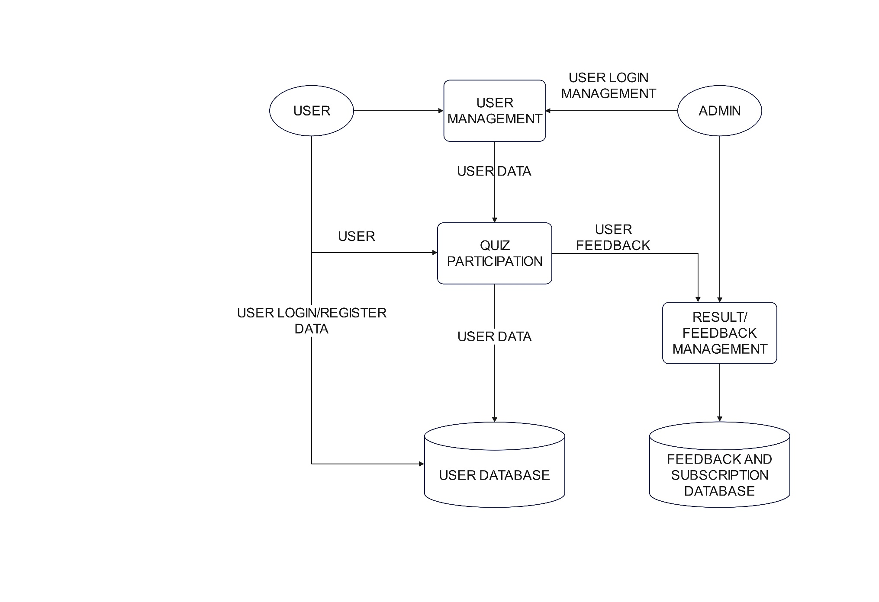

4.2 DATA FLOW DIAGRAM

LEVEL 0
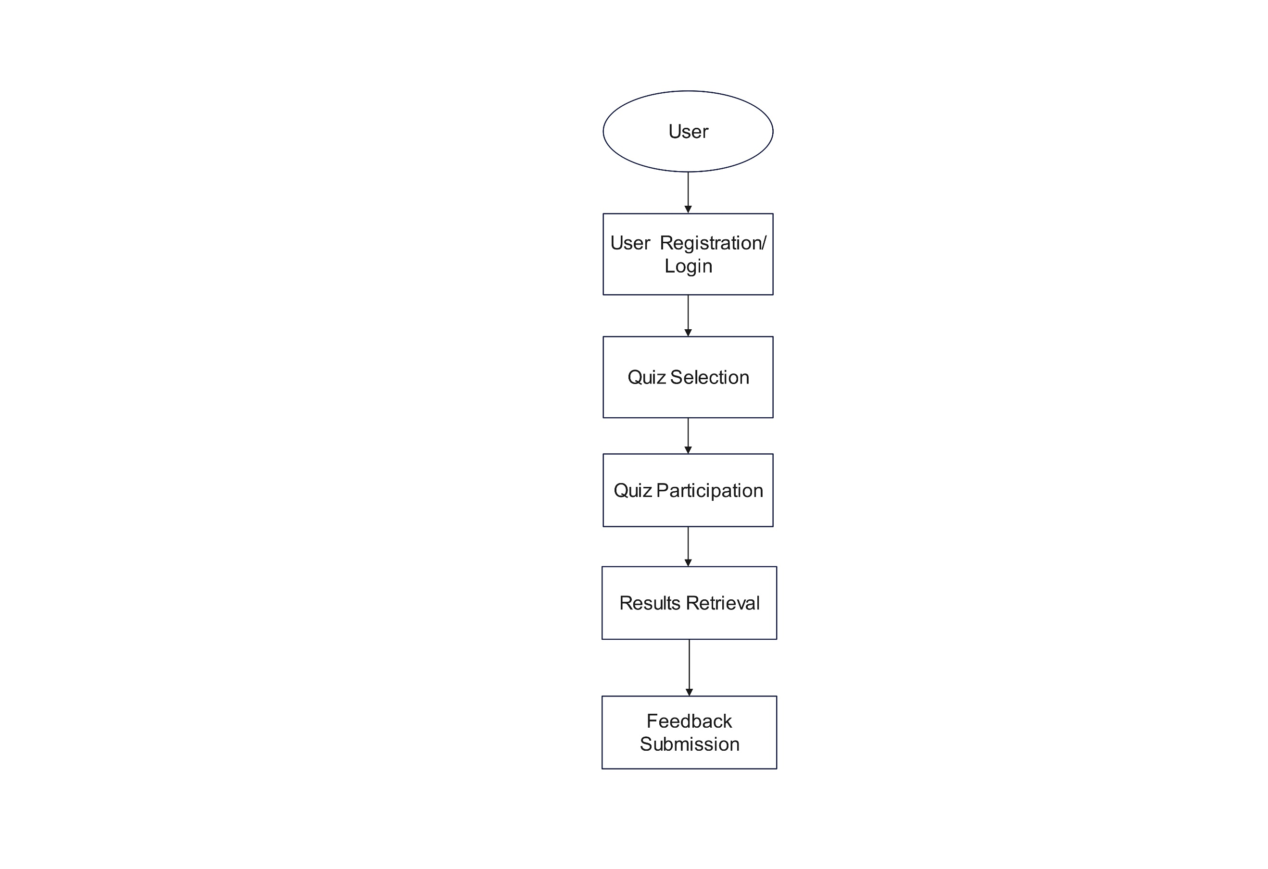

LEVEL 1
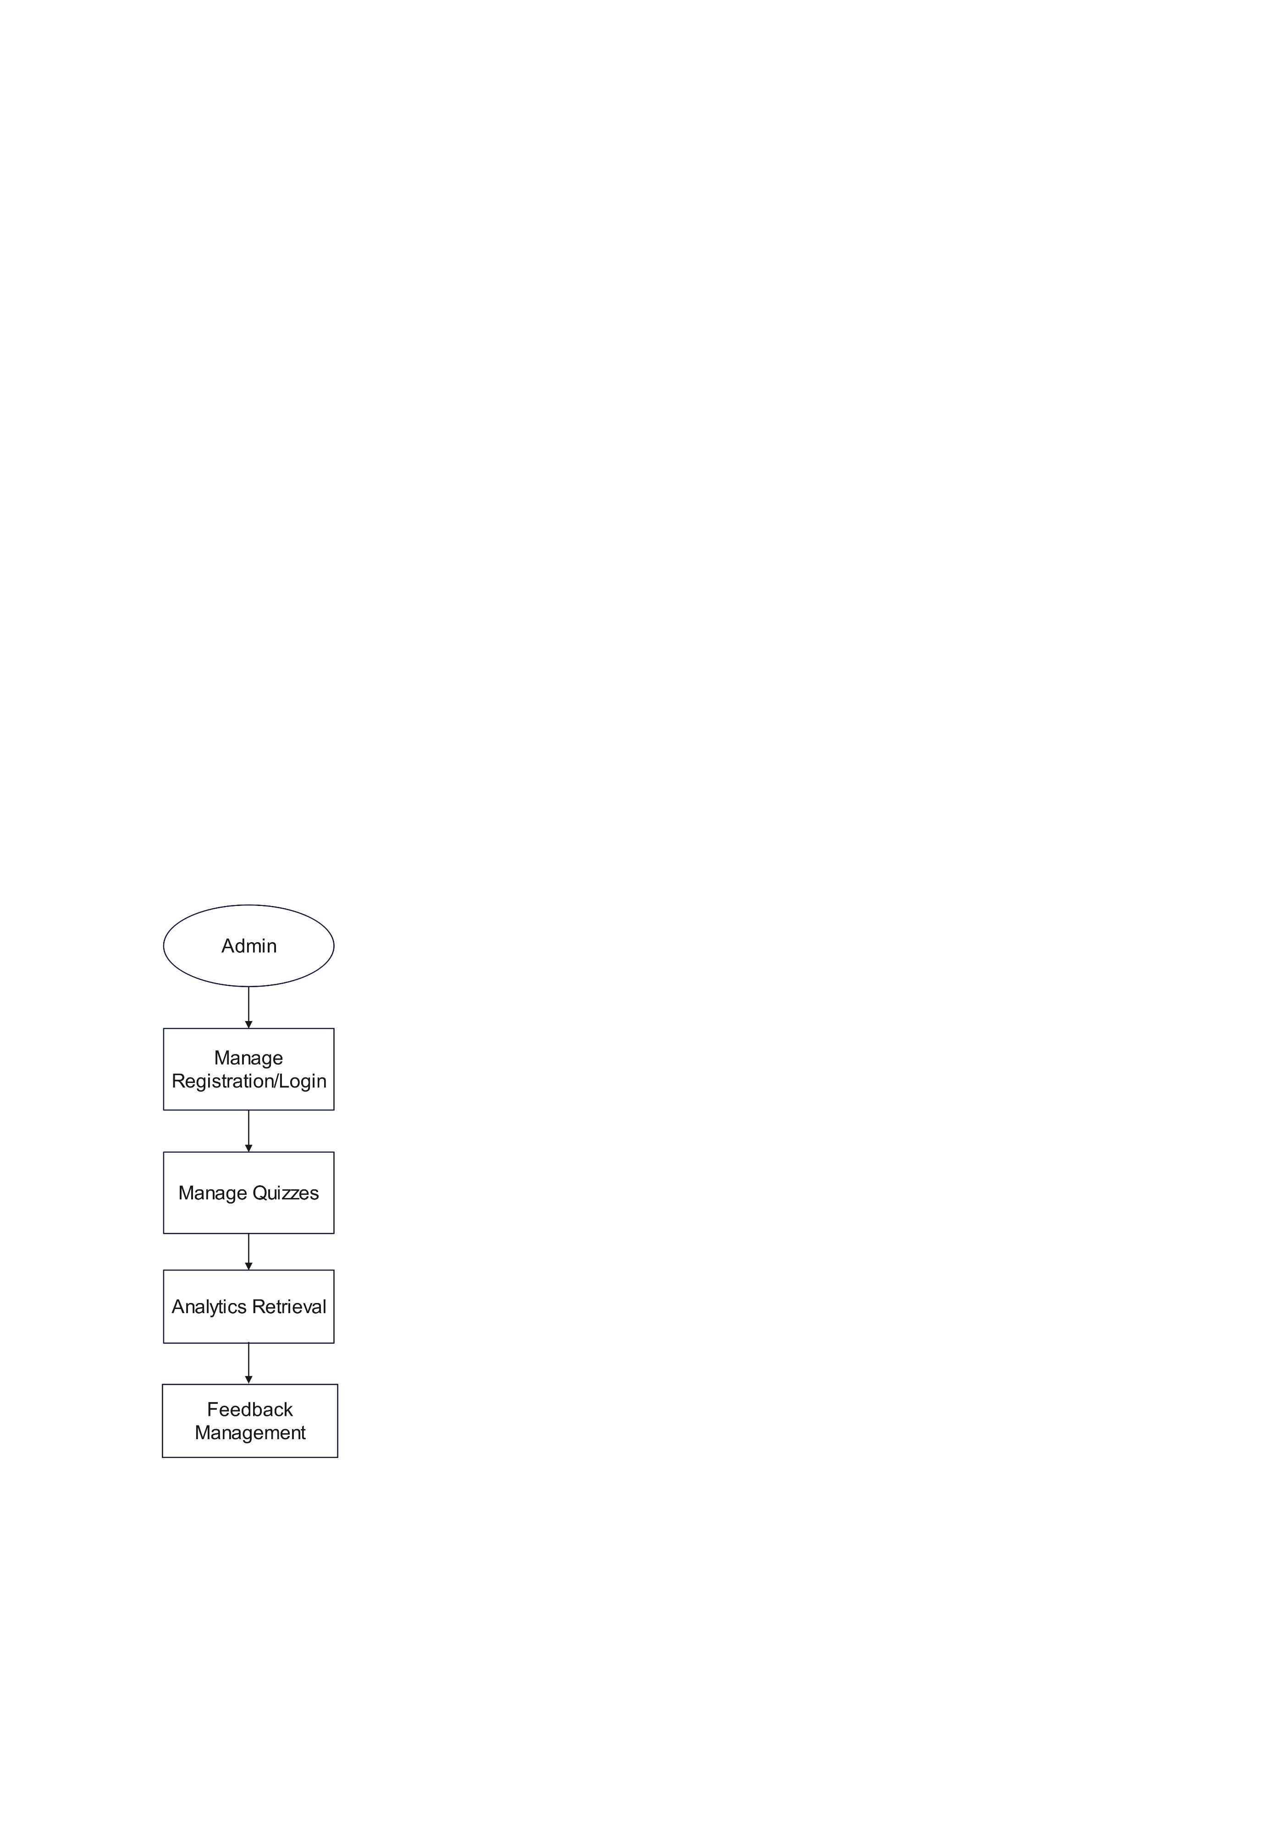

DATABASE SCHEMA TABLE
Users Table:

Column Name | Data Type | Constraints
id | int(11) | PRIMARY KEY, AUTO_INCREMENT
name | varchar(100) | NOT NULL
registration_no | varchar(50) | NOT NULL, UNIQUE
email | varchar(100) | NOT NULL, UNIQUE
phone_no | varchar(15) | NOT NULL
class | varchar(50) | NOT NULL
password | varchar(255) | NOT NULL

Subscriptions Table:

Column Name | Data Type | Constraints
id | int(11) | PRIMARY KEY, AUTO_INCREMENT
email | varchar(255) | NOT NULL, UNIQUE
subscribed_at | timestamp | NOT NULL DEFAULT CURRENT_TIMESTAMP

Reviews Table:

Column Name | Data Type | Constraints
id | int(11) | PRIMARY KEY, AUTO_INCREMENT
name | varchar(255) | NOT NULL
phone | varchar(20) | DEFAULT NULL
email | varchar(255) | NOT NULL
message | text | NOT NULL
submitted_at | timestamp | NOT NULL DEFAULT CURRENT_TIMESTAMP

Contact Table:

Column Name | Data Type | Constraints
id | int(11) | PRIMARY KEY, AUTO_INCREMENT
name | varchar(255) | NOT NULL
phone | varchar(20) | DEFAULT NULL
email | varchar(255) | NOT NULL
message | text | NOT NULL
submitted_at | timestamp | NOT NULL DEFAULT CURRENT_TIMESTAMP

6. SYSTEM DEVELOPMENT
Module Description:
In system development, a module is a self-contained component of a software system that performs a specific function or set of related functions. Each module is designed to be independent, allowing developers to work on different parts of the system simultaneously. This modular approach enhances code organization, making it easier to manage, test, and maintain the software. Modules can be reused across different projects, saving time and effort. They typically include their own code, data, and interfaces, enabling clear communication with other modules. Overall, modules help streamline the development process and improve the overall quality of the software system. There the different types of modules used in Knowzilla,
User Management Module:
  - Purpose: This module handles all user-related functionalities, including registration, login, and profile management.
  - Features:
    - User Registration: Allows new users to create an account by providing their name, email, phone number, registration number, class, and password.
    - User Login: Authenticates users by verifying their credentials (email and password).
    - Profile Management: Enables users to update their personal information and change their passwords.
Quiz Module:
  - Purpose: This module is responsible for managing the quiz functionalities, including displaying questions and recording user responses.
  - Features:
    - Quiz Selection: Users can choose from a list of available quizzes.
    - Question Display: Presents quiz questions to users, allowing them to select answers.
    - Score Calculation: Automatically calculates and displays the user's score upon completion of the quiz.
Feedback and Review Module:
  - Purpose: This module allows users to submit feedback and reviews about their quiz experience.
  - Features:
    - Review Submission: Users can submit their reviews, including their name, email, phone number, and feedback message.
    - Review Display: Displays submitted reviews on the website for other users to see, enhancing community engagement.
Subscription Module:
  - Purpose: This module manages user subscriptions for updates and newsletters.
  - Features:
    - Email Subscription: Users can enter their email addresses to subscribe to updates about new quizzes and features.
    - Subscription Management: Allows users to manage their subscription status, ensuring they receive relevant information.
Contact Module:
  - Purpose: This module facilitates communication between users and the website administrators.
  - Features:
    - Contact Form: Users can fill out a form to send messages or inquiries to the website administrators.
    - Message Storage: Stores submitted messages in the database for review by the administrators.

7. SYSTEM TESTING

System testing is a phase in the software testing process where the complete and integrated software system is evaluated to ensure it meets specified requirements. This type of testing is conducted in an environment that closely resembles the production environment. The primary goal is to validate the end-to-end system specifications and to identify any defects before the software is deployed. System testing encompasses various types of tests, including functional, performance, security, and usability testing, ensuring that the software behaves as expected under different conditions. It is typically performed by a dedicated testing team and serves as a critical step in delivering high-quality software.
Types of Testing:
Functional Testing:
  - Objective: Verify that the system functions according to the specified requirements.
  - Methodology: Test each function of the application by providing appropriate input and verifying the output against the expected results.
  - Test Cases:
    - User registration with valid and invalid data.
    - User login with correct and incorrect credentials.
    - Quiz creation by admin and retrieval by users.
    - Submission of quiz answers and calculation of scores.
  - Role: QA Engineers / Testers
  - Responsibilities:
    - Develop and execute test cases based on functional requirements and user stories.
    - Validate that all features of the application (e.g., quiz creation, user registration, result retrieval) work as intended.
    - Report defects and verify fixes to ensure functionality meets specifications.
Non-Functional Testing:
  - Objective: Assess the performance, usability, reliability, and security of the system.
  - Methodology: Evaluate the system under various conditions to ensure it meets performance benchmarks and user experience standards.
  - Test Cases:
    - Load testing to determine how the system performs under heavy user traffic.
    - Stress testing to identify the system's breaking point.
    - Usability testing to evaluate the user interface and user experience.
    - Security testing to identify vulnerabilities and ensure data protection.
  - Role: QA Engineers / Performance Test Engineers
  - Responsibilities:
    - Conduct tests to evaluate non-functional aspects such as performance, security, usability, and compatibility.
    - Assess how the application performs under various conditions (load, stress) and ensure it meets security standards.
    - Gather user feedback on usability and ensure compatibility across different devices and browsers.
Integration Testing:
  - Objective: Verify that different modules or services within the application work together as intended.
  - Methodology: Test the interactions between integrated components to ensure they function correctly.
  - Test Cases:
    - Interaction between the User Management and Quiz Management modules.
    - Data flow between the Quiz Participation and Results Management processes.
    - Integration of the front-end interface with the back-end database.
  - Role: Developers / QA Engineers
  - Responsibilities:
    - Test the interactions between integrated components or modules to ensure they work together correctly.
    - Developers may perform initial integration tests, while QA engineers conduct more comprehensive tests to validate the integration points.
    - Identify and resolve issues related to data flow and communication between modules.
Regression Testing:
  - Objective: Ensure that new code changes do not adversely affect existing functionalities.
  - Methodology: Re-run previously conducted tests after changes to the codebase.
  - Test Cases:
    - Re-testing user registration and login after updates to the User Management module.
    - Verifying quiz functionality after changes to the Quiz Management module.
  - Role: QA Engineers / Testers
  - Responsibilities:
    - Re-test the application after changes (such as bug fixes or new features) to ensure that existing functionality remains unaffected.
    - Maintain a suite of regression tests to automate the process where possible, ensuring efficiency in testing.
    - Document any issues found during regression testing and verify that fixes do not introduce new defects.
User Acceptance Testing (UAT):
  - Objective: Validate the system against user requirements and ensure it meets their expectations.
  - Methodology: Conduct testing with actual users to gather feedback and identify any issues.
  - Test Cases:
    - Real users performing registration, taking quizzes, and providing feedback.
    - Gathering user feedback on the overall experience and usability of the platform.
  - Role: End Users / Stakeholders
  - Responsibilities:
    - Test the application in real-world scenarios to ensure it meets user needs and expectations.
    - Provide feedback on usability, functionality, and overall satisfaction before the final release.
    - Validate that the application aligns with business requirements and is ready for deployment.

8. PROJECT IMPLEMENTATION

Project implementation is the phase in project management where the planned project activities are executed to achieve the project's objectives. This stage involves putting the project plan into action, coordinating resources, and managing tasks to ensure that everything is completed on time and within budget. Key activities during project implementation include assigning tasks to team members, monitoring progress, addressing any issues that arise, and ensuring effective communication among stakeholders. Successful implementation requires careful management and adaptability to changes, ensuring that the project meets its goals and delivers the expected outcomes. Overall, project implementation is crucial for turning ideas into reality and achieving project success.
Project Planning and Preparation:
- Define Objectives: Clearly outline the goals of the "KNOWZILLA" project, including the target audience, key features, and expected outcomes.
- Resource Allocation: Identify team members, their roles, and responsibilities. Allocate resources such as hardware, software, and budget.
- Timeline Creation: Develop a project timeline with milestones, deadlines, and deliverables.
System Design:
- Architecture Design: Define the overall architecture of the application, including client-server interactions, database design, and third-party integrations.
- User Interface (UI) Design: Create wireframes and mockups for the user interface, focusing on usability and user experience.
- Database Design: Design the database schema, including tables for users, quizzes, questions, and results. Define relationships and constraints.
Development Environment Setup:
- Development Tools: Set up the development environment with necessary tools, including:
  - Code editor (e.g., Visual Studio Code, Sublime Text)
  - Version control system (e.g., Git)
  - Local server environment (e.g., XAMPP, WAMP for PHP and MySQL)
- Frameworks and Libraries: Choose and install relevant frameworks and libraries (e.g., Bootstrap for CSS, jQuery for JavaScript).
Coding and Development:
- Front-End Development:
  - Implement the user interface using HTML, CSS, and JavaScript.
  - Ensure responsive design for compatibility across devices.
  - Integrate client-side validation for forms (e.g., registration, quiz answers).
- Back-End Development:
  - Develop server-side logic using PHP to handle user authentication, quiz management, and data processing.
  - Implement RESTful APIs for communication between the front end and back end.
  - Connect to the MySQL database to store and retrieve data.
- Database Implementation:
  - Create the database and tables based on the designed schema.
  - Populate the database with initial data (e.g., sample quizzes and questions).
Integration:
- Integrate Front-End and Back-End: Ensure seamless communication between the front-end interface and back-end logic.
- Third-Party Integrations: If applicable, integrate third-party services (e.g., payment gateways, analytics tools).

Deployment:
- Prepare for Deployment:
  - Choose a hosting provider (e.g., AWS, Digital Ocean, shared hosting).
  - Set up the production environment, including server configuration and database setup.
- Deploy the Application:
  - Upload the application files to the server.
  - Import the database and configure connection settings.
- Domain Setup: Register a domain name and configure DNS settings to point to the hosting server.
Post-Deployment Activities:
- Monitoring and Maintenance:
  - Monitor the application for performance, security, and user feedback.
  - Address any issues or bugs that arise post-deployment.
- User Support: Provide support channels for users to report issues or seek assistance.
- Updates and Enhancements: Plan for future updates, feature enhancements, and regular maintenance.
Documentation:
- Technical Documentation: Create documentation for developers, including code comments, API documentation, and architecture diagrams.
- User Documentation: Develop user manuals or guides to help users navigate the platform and utilize its features.

9. CONCLUSION

Knowzilla is a robust knowledge management platform designed to help organizations effectively capture, organize, and share information, thereby enhancing collaboration and decision-making. By centralizing knowledge in a single repository, it allows users to easily access various content types, including documents and videos, while promoting teamwork through features like real-time editing and commenting. Its customizable interface enables organizations to tailor the platform to their specific workflows, ensuring relevance and effectiveness. Additionally, Knowzilla offers analytics tools to track knowledge usage and identify gaps, allowing businesses to make informed decisions about their knowledge management strategies. Overall, Knowzilla empowers teams to leverage their collective knowledge, driving efficiency, innovation, and continuous improvement within the organization.

10. FUTURE ENHANCEMENTS

Future enhancements for the "KNOWZILLA" quiz trivia website will focus on user experience improvements, advanced quiz features, gamification elements, community and social features, and robust analytics and reporting. The user interface will be revamped for a modern, visually appealing design with intuitive navigation and personalized dashboards that track quiz history and performance. A dedicated mobile app for iOS and Android will enhance accessibility and engagement. Advanced quiz features will include timed quizzes for added excitement, multimedia questions for interactivity, and adaptive quizzes that adjust difficulty based on user performance. Gamification will be emphasized through competitive leaderboards, a system of badges and achievements, and daily or weekly challenges to encourage regular participation. Community features will allow users to create profiles, connect with friends, and engage in discussion forums, while enabling user-generated content will diversify quiz offerings. Finally, an advanced analytics dashboard will provide users with insights into their performance, and admin analytics will facilitate data-driven decision-making, complemented by a feedback mechanism to ensure the platform continuously meets user needs.

11. BIBLIOGRAPHY

- https://www.nngroup.com/articles/usability-101-introduction-to-usability/
- https://www.w3schools.com/html/
- https://developer.mozilla.org/en-US/docs/Web/JavaScript/Guide
- https://getbootstrap.com/docs/5.0/getting-started/introduction/
- https://www.mindtrek.org/2011/Proceedings/2011-MindTrek-Conference-Proceedings.pdf
- https://www.smashingmagazine.com/2018/01/ux-design-process/
- https://www.edutopia.org/article/gamification-education
- https://www.quizlet.com
- https://www.kahoot.com
- https://www.socrative.com

APPENDIX

Appendix A: Output Screenshot

HOME PAGE:

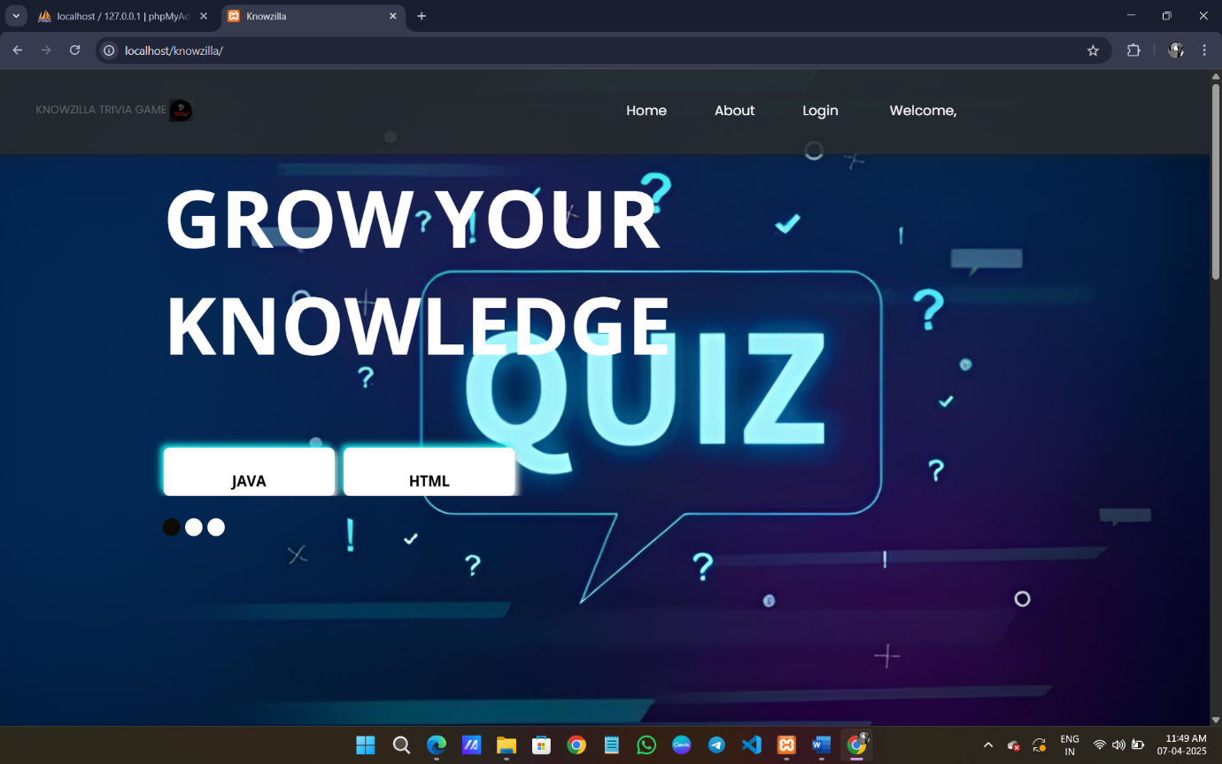

C PAGE:

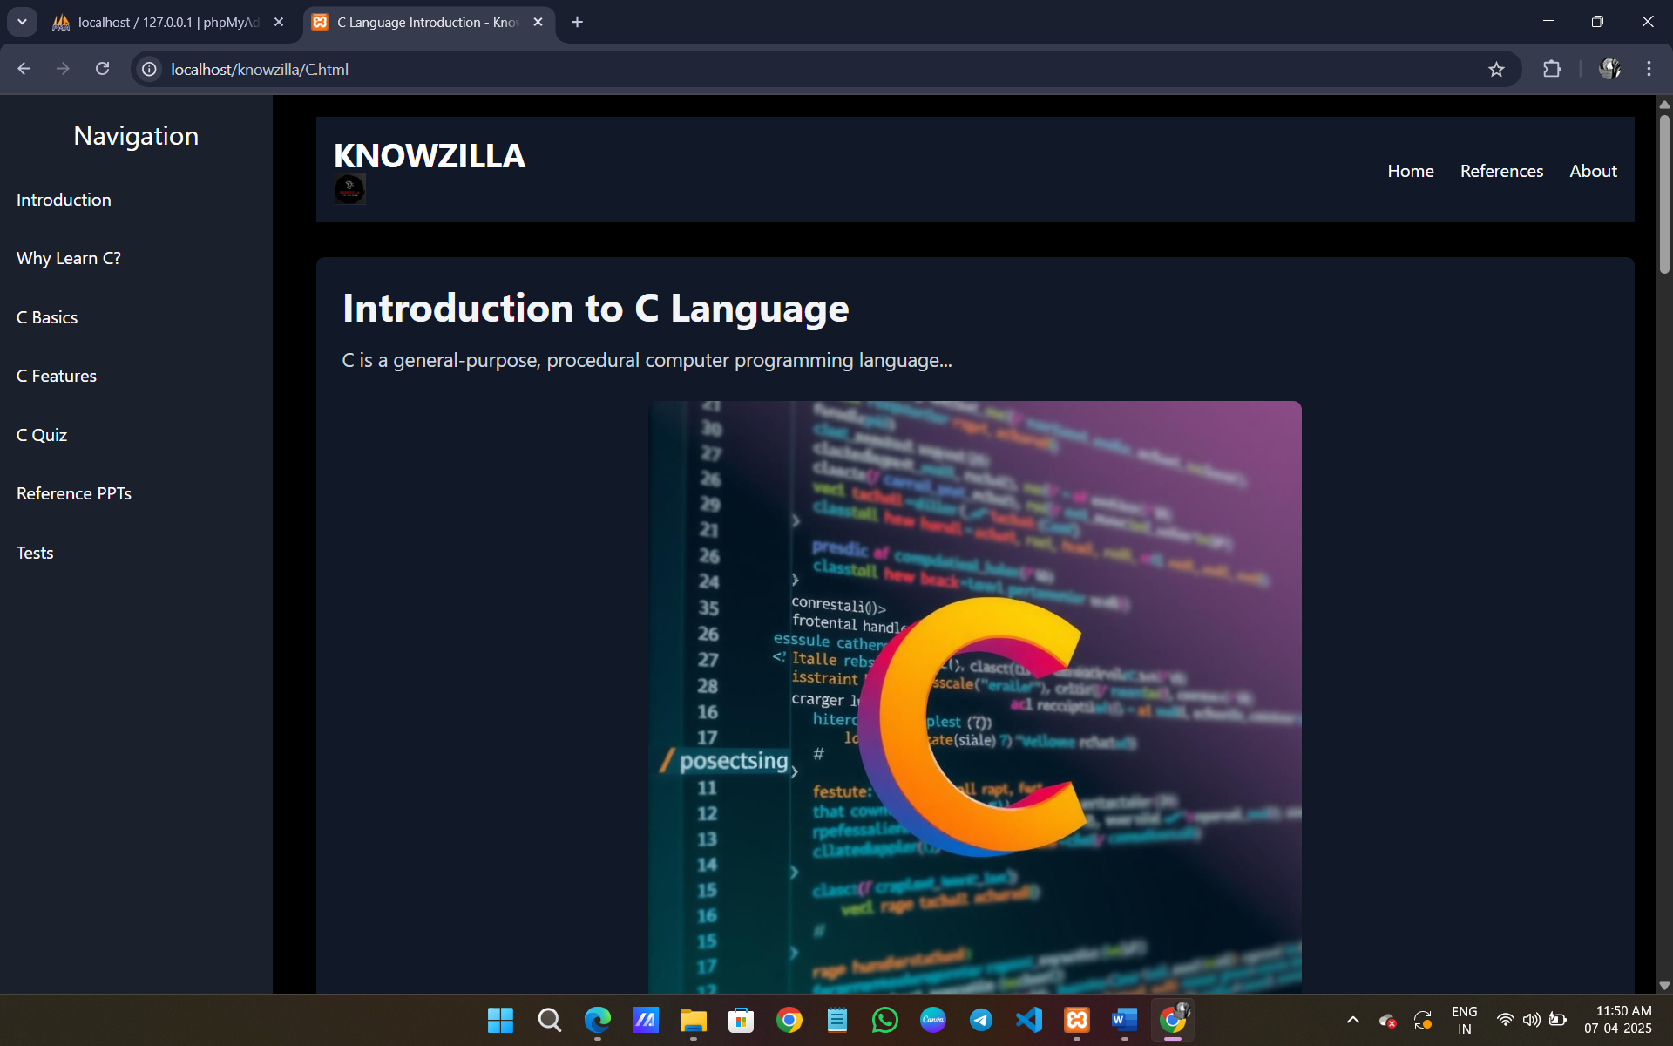

QUIZ PAGE:

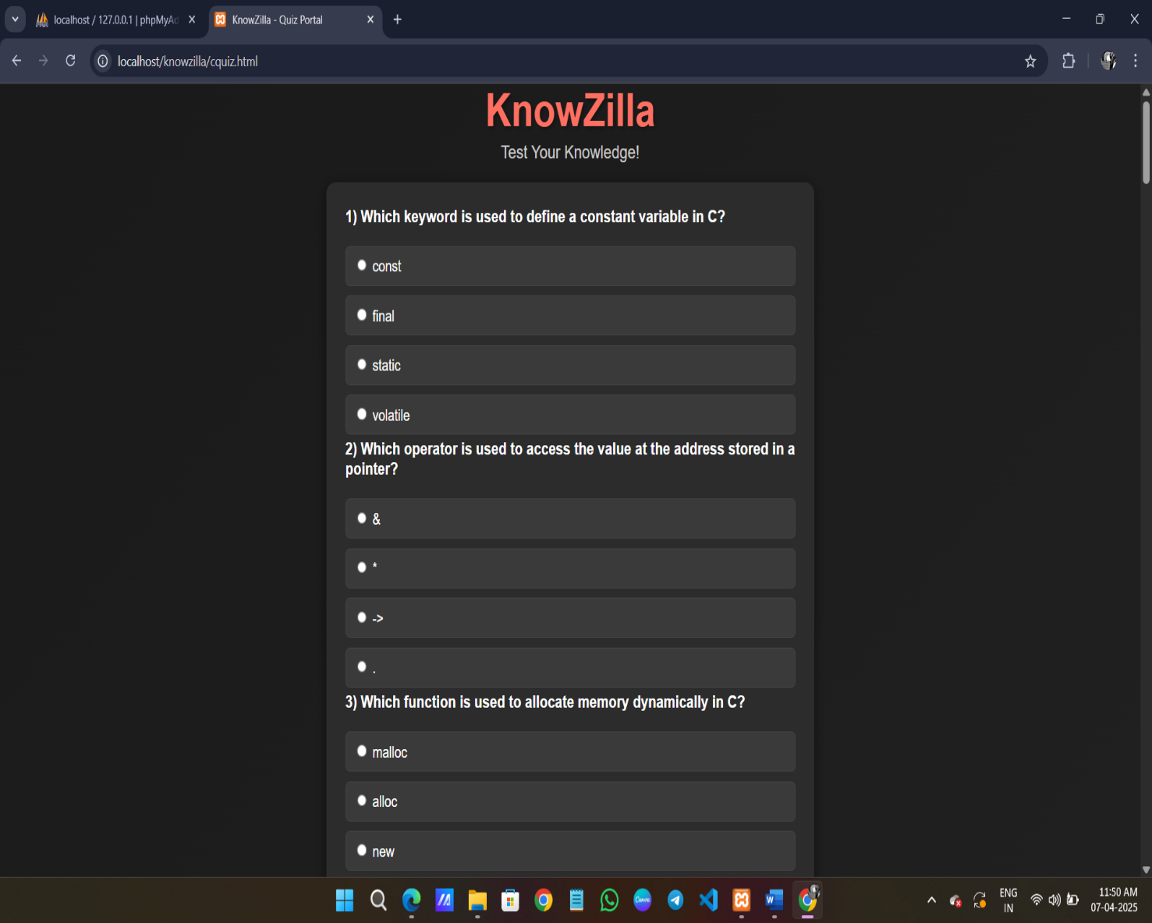

RESULT PAGE:

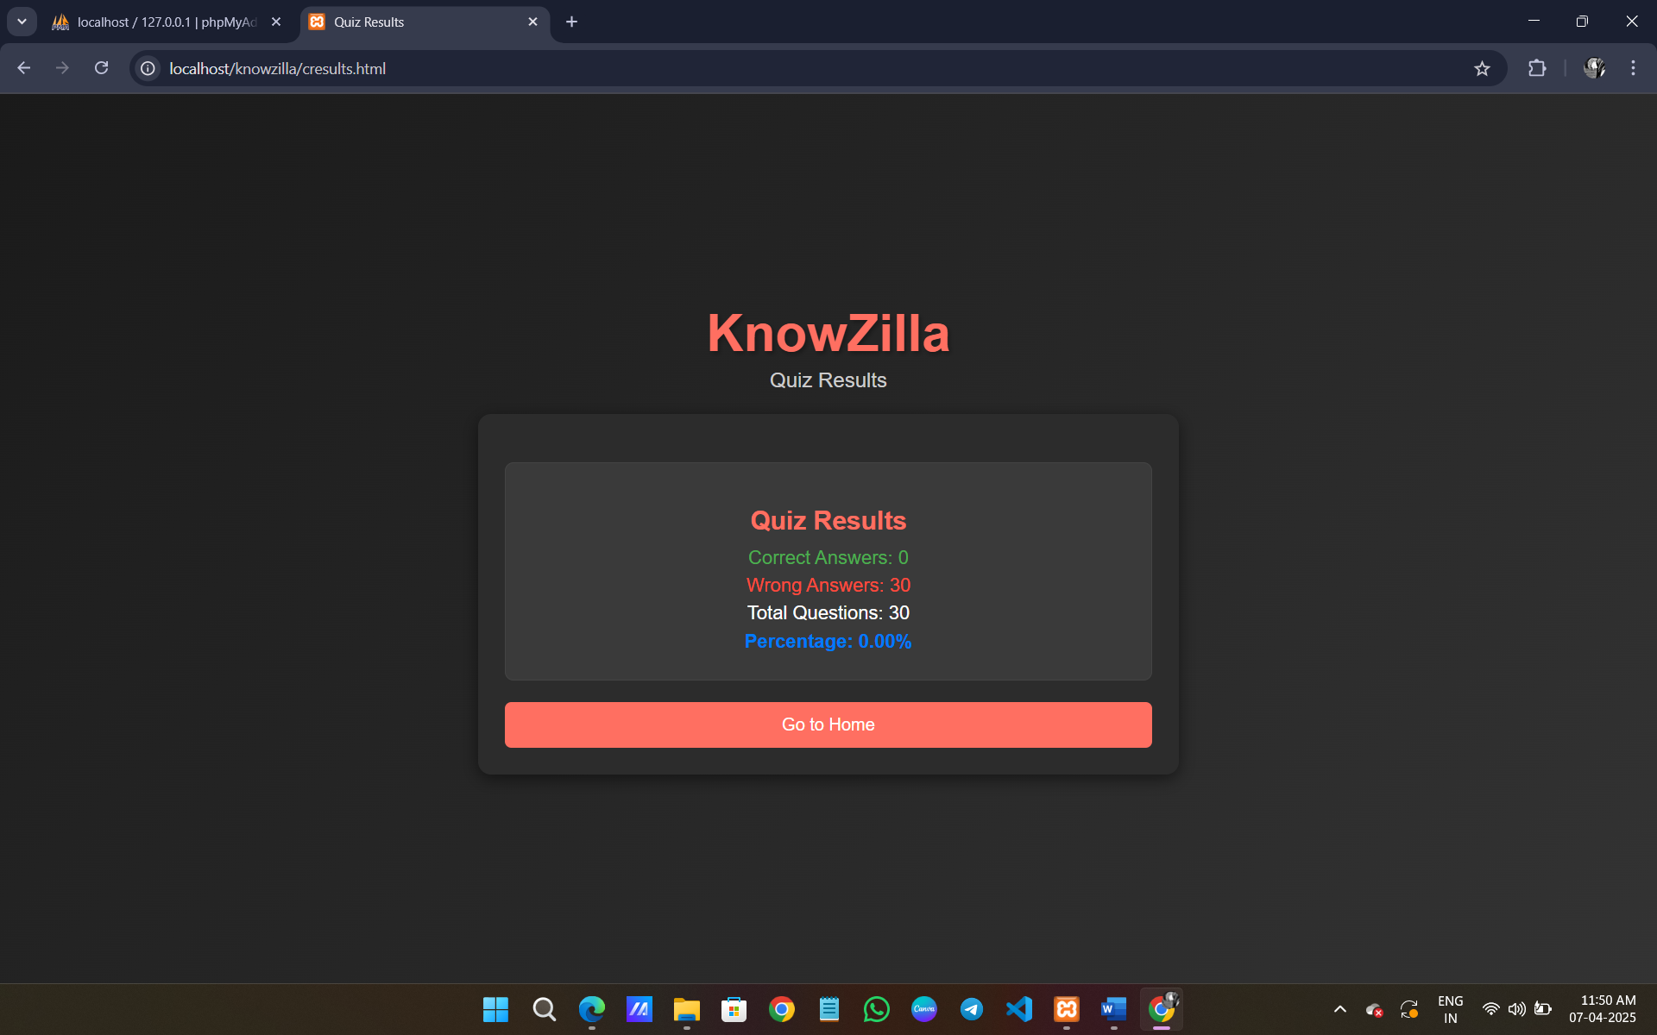

LOGIN PAGE:
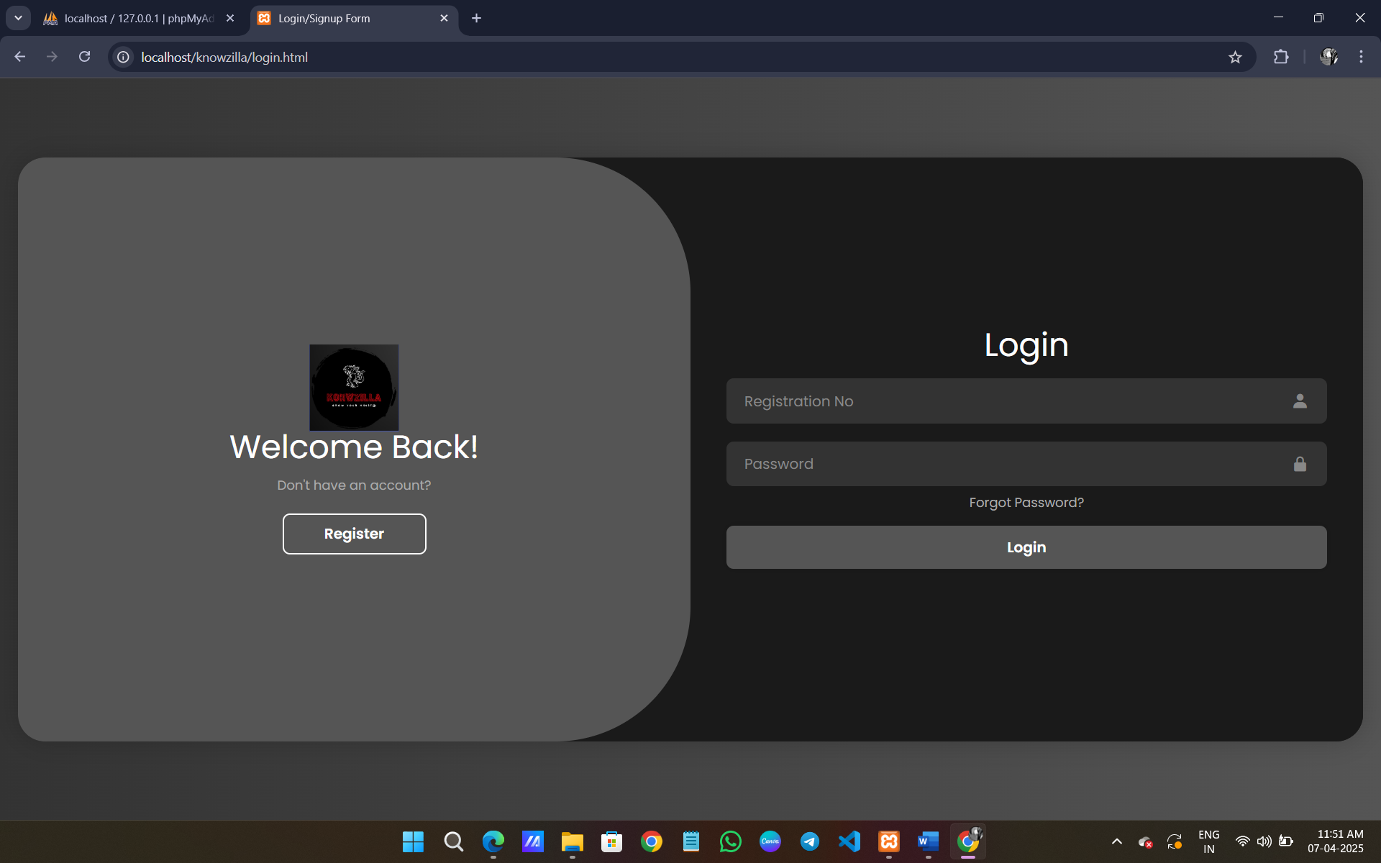

SIGNUP PAGE:

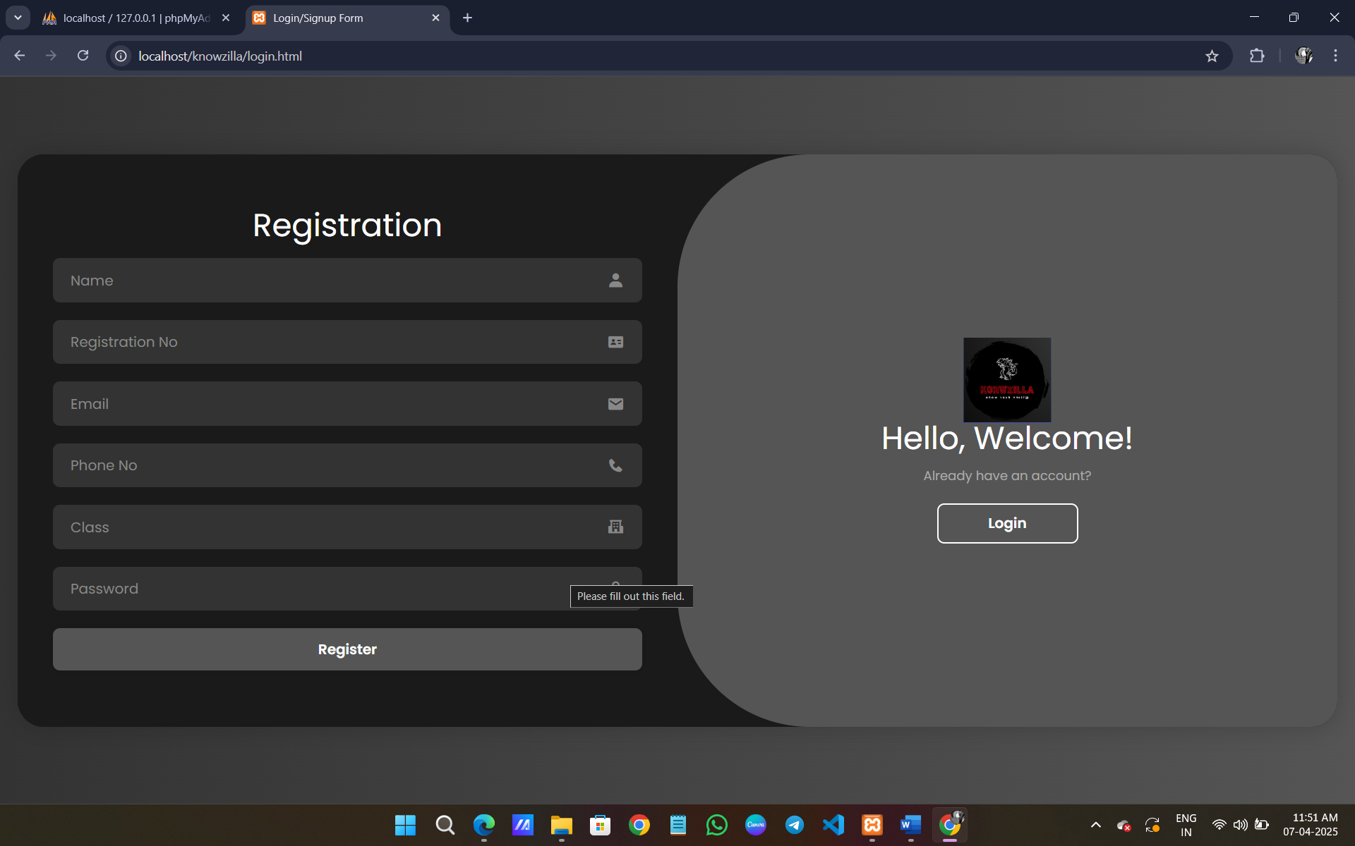

Appendix B: Sample Coding

<!DOCTYPE html>
<html lang="en">
<head>
<!-- basic -->
<meta charset="utf-8">
<meta http-equiv="X-UA-Compatible" content="IE=edge">
<!-- mobile metas -->
<meta name="viewport" content="width=device-width, initial-scale=1">
<meta name="viewport" content="initial-scale=1, maximum-scale=1">
<!-- site metas -->
<title>Knowzilla</title>
<meta name="keywords" content="">
<meta name="description" content="">
<meta name="author" content="">
<!-- bootstrap css -->
<link rel="stylesheet" href="css/bootstrap.min.css">
<!-- style css -->
<link rel="stylesheet" href="css/style.css">
<!-- responsive-->
<link rel="stylesheet" href="css/responsive.css">
<!-- awesome fontfamily -->
<linkrel="stylesheet"href="https://cdnjs.cloudflare.com/ajax/libs/font-awesome/4.7.0/css/font-awesome.min.css">
<script src="https://oss.maxcdn.com/html5shiv/3.7.3/html5shiv.min.js"></script>
<script src="https://oss.maxcdn.com/respond/1.4.2/respond.min.js"></script><![endif]-->
</head>
<!-- body -->
<body class="main-layout">
<!-- loader -->
<div class="loader_bg">
<div class="loader"><img src="images/loading.gif" alt="" /></div>
</div>
<!-- end loader -->
<!-- header -->
<header>
<div class="header">
<div class="container-fluid">
<div class="row d_flex">
<div class="col-md-2 col-sm-3 col logo_section">
<div class="full">
<div class="center-desk">
<div class="logo">KNOWZILLA TRIVIA GAME
<a href="index.html"><img src="logo.png" width="30" height="20"></a>
</div>
</div>
</div>
</div>
<div class="col-md-8 col-sm-9">
<nav class="navigation navbar navbar-expand-md navbar-dark ">
<button class="navbar-toggler" type="button" data-toggle="collapse" data-target="#navbarsExample04" aria-controls="navbarsExample04" aria-expanded="false" aria-label="Toggle navigation">
<span class="navbar-toggler-icon"></span>
</button>
<div class="collapse navbar-collapse" id="navbarsExample04">
<ul class="navbar-nav mr-auto">
<li class="nav-item active">
<a class="nav-link" href="index.html">Home</a>
</li>
<li class="nav-item">
<a class="nav-link" href="about.html">About</a>
</li>
<li class="nav-item">
<a class="nav-link" href="login.html">Login&nbsp;</a>
</li>
<!-- Display username if logged in -->
<?php session_start(); if (isset($_SESSION['username'])): ?>
<li class="nav-item">
<span class="nav-link">Welcome, <?php echo htmlspecialchars($_SESSION['username']); ?></span>
</li>
<?php endif; ?>
</ul>
</div>
</nav>
</div>
<div class="col-md-2 d_none">
<ul class="email text_align_right">
<!-- Additional email or contact links can go here -->
</ul>
</div>
</div>
</div>
</div>
</header>
<!-- end header -->
<!-- start slider section -->
<div id="top_section" class="banner_main">
<div class="container">
<div class="row">
<div class="col-md-12">
<div id="myCarousel" class="carousel slide" data-ride="carousel">
<ol class="carousel-indicators">
<li data-target="#myCarousel" data-slide-to="0" class="active"></li>
<li data-target="#myCarousel" data-slide-to="1"></li>
<li data-target="#myCarousel" data-slide-to="2"></li>
</ol>
<div class="carousel-inner">
<div class="carousel-item active">
<div class="container-fluid">
<div class="carousel-caption relative">
<div class="bluid">
<h1> GROW YOUR</h1>
<h1>KNOWLEDGE&nbsp;</h1>
<p><br></p>
<a class="read_more" href="java.html"style="color:black;">JAVA</a>
<a class="read_more" href="html.html"style="color:black;"> HTML</a>
</div>
</div>
</div>
</div>
<div class="carousel-item">
<div class="container-fluid">
<div class="carousel-caption relative">
<div class="bluid">
<h1>GROW YOUR<br>KNOWLEDGE </h1>
<p><br></p>
<a class="read_more" href="C.html"style="color:black;">C </a>
<a class="read_more" href="c++.html"style="color:black;">C++</a>
</div>
</div>
</div>
</div>
<div class="carousel-item">
<div class="container-fluid">
<div class="carousel-caption relative">
<div class="bluid">
<h1>GROW YOUR <br>KNOWLEDGE </h1>
<a class="read_more" href="python.html"style="color:black;">PYTHON</a>
<a class="read_more" href="javascript.html"style="color:black;">JAVASCRIPT</a>
</div>
</div>
</div>
</div>
</div>
<a class="carousel-control-prev" href="#myCarousel" role="button" data-slide="prev">
<i class="fa fa-angle-left" aria-hidden="true"></i>
<span class="sr-only">Previous</span>
</a>
<a class="carousel-control-next" href="#myCarousel" role="button" data-slide="next">
<i class="fa fa-angle-right" aria-hidden="true"></i>
<span class="sr-only">Next</span>
</a>
</div>
</div>
</div>
</div>
</div>
<!-- end slider section -->
<!-- we_do -->
<div class="we_do">
<div class="container">
<div class="row">
<div class="col-md-12">
<div class="titlepage text_align_center">
<h2>&nbsp; </h2>
</div> </div> </div>
<!-- end footer -->
<!-- Javascript files-->
<script src="js/jquery.min.js"></script>
<scriptsrc="js/bootstrap.bundle.min.js"></script><scriptsrc="js/jquery-3.0.0.min.js"></script>
<script src="js/custom.js"></script>
</body></html>

